**Part 1: Create a Simple Freestyle Job and Run a Shell Command**

**STEP 1 :** **Click on Create new jobs.**

**1st : click on new item in dashboard**

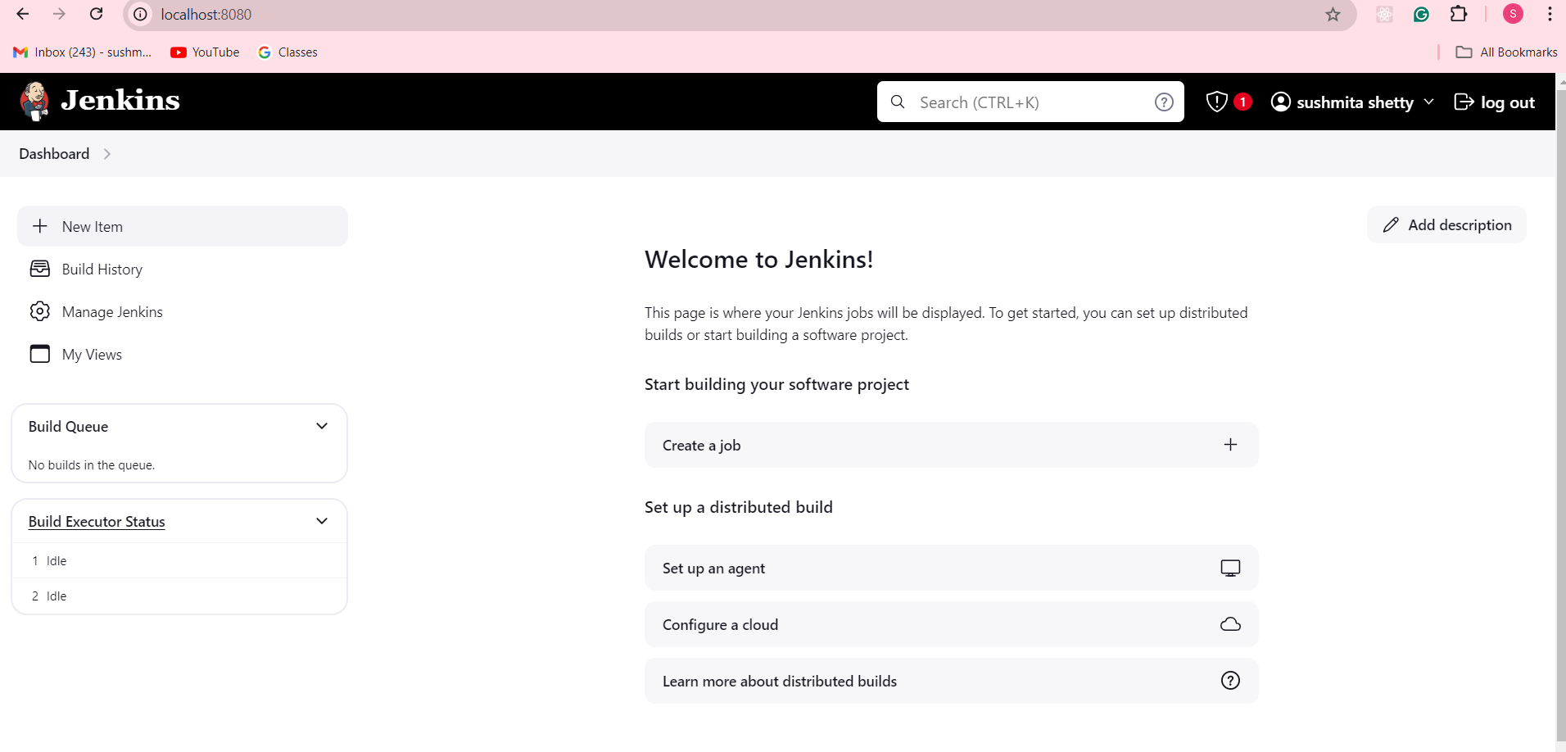

**Step 2: Now Specify a name to the project as “Example1” , select option “Freestyle project“ and click on the OK button**

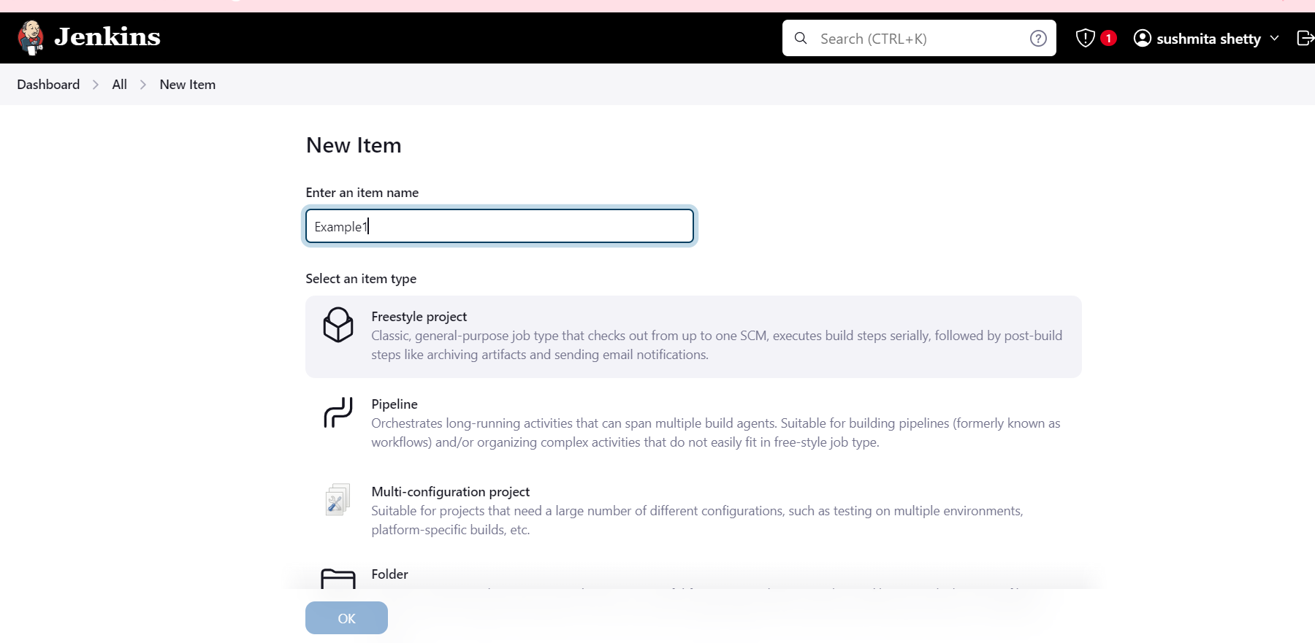

**Step3-: In this project, we are going to learn how to run a simple shell script on Jenkins. So, Click on Build option and select Execute script/shell from the dropdown menu**

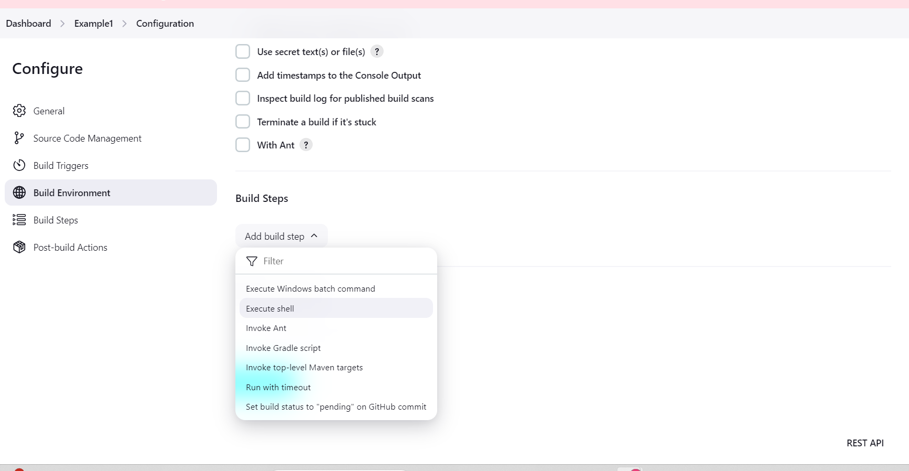

**Step4-: Now Write a Simple Shell command to print the text. then click on apply followed by save button.**

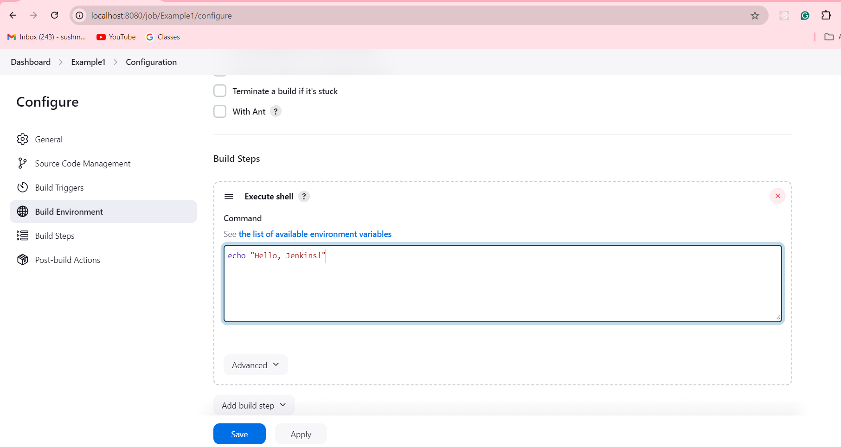

**Step5-: Now Build a project to see the output**

**After saving, click Build Now on the project’s dashboard.**

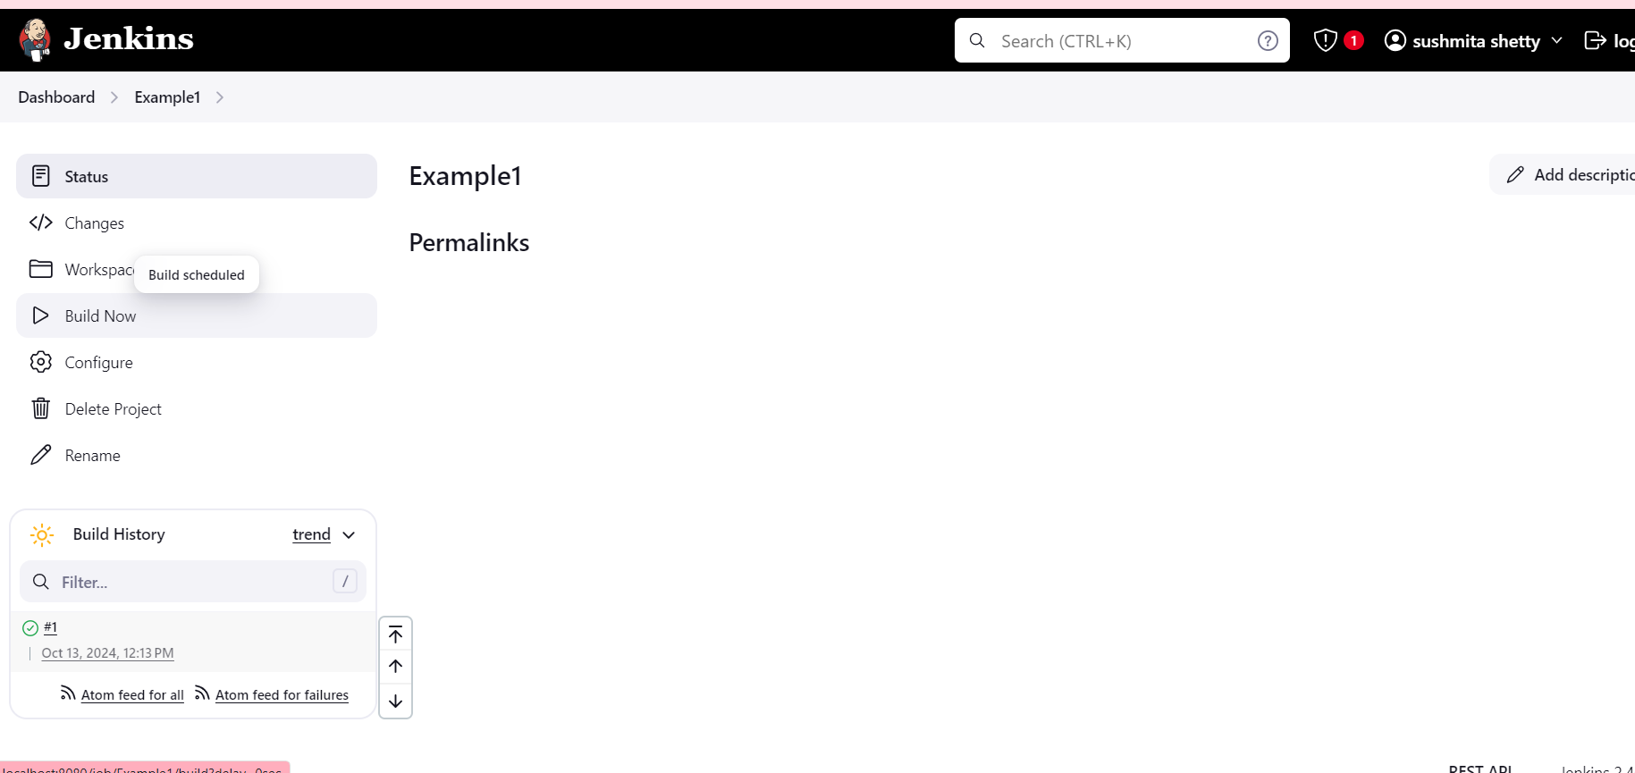

**Check the output by clicking on the build number (e.g., #1) and then Console Output to see the result.**

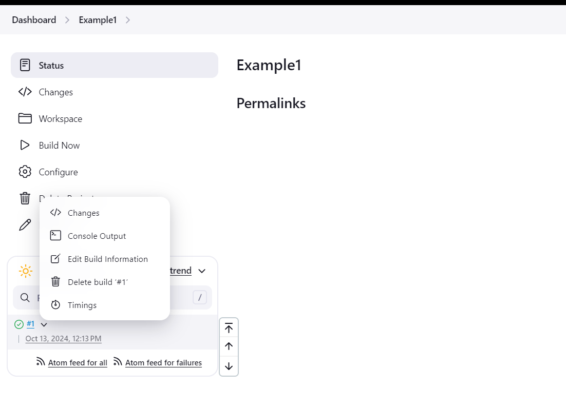

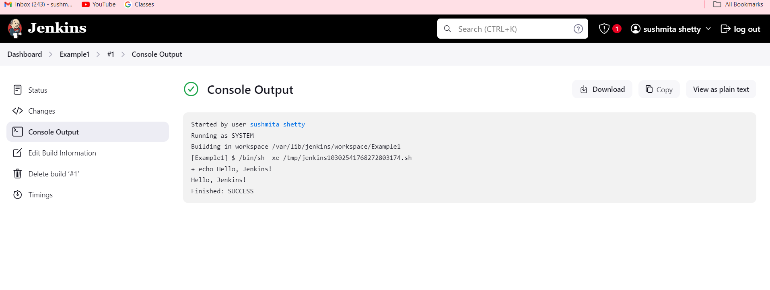

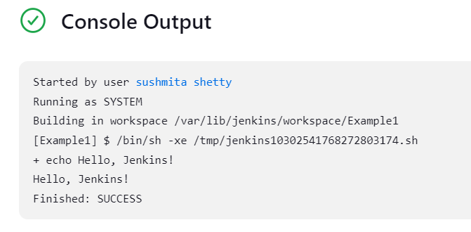

**Part 2: Parameterizing a Build in Jenkins**

**Example1.2: Now let us take parameters through files. So, create a new shell script file in the local directory. Now first run the shell script locally with no parameter,one parameter, and two parameters. Now Let us run it through Jenkins Shell.**

**Create a Shell Script Locally:**

* **Open a text editor (e.g., Notepad++ or Visual Studio Code) and create a new file called example.sh.**

**Add the following code to the shell script:**

**#!/bin/bash**

**if [ "$#" -eq 0 ]; then**

**echo "No parameters provided."**

**elif [ "$#" -eq 1 ]; then**

**echo "Hello, $1!"**

**else**

**echo "Hello, $1! You are from $2."**

**fi # Corrected from 'Fi' to 'fi'**

**add this above code in example.sh (nano)**

**Create the example.sh file using terminal only :**

**1st : give the path**



**2nd : run the below command this will open a terminal paste the above given code there.**

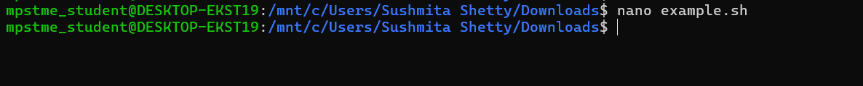

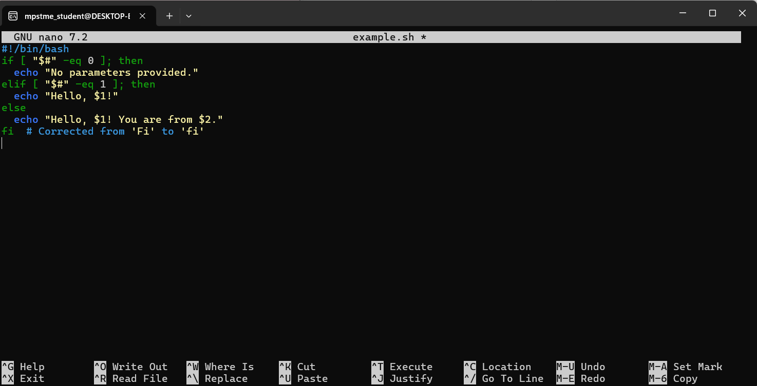

**Save the file by pressing CTRL + X, then Y to confirm, and press Enter.**

**THEN EXECUTE :**



**AFTER THAT LETS RUN ONE BY ONE**

**1ST: No PARAMETER :**

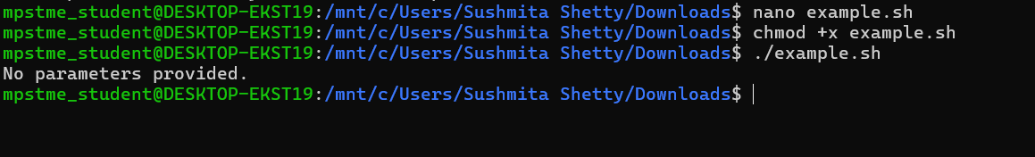

**2ND : ONE PARAMETER**

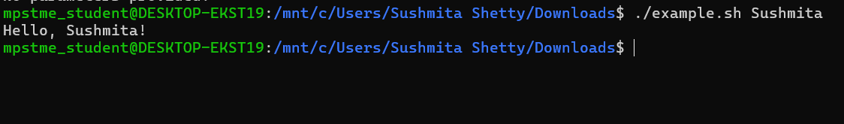

**3rd : two parameter:**

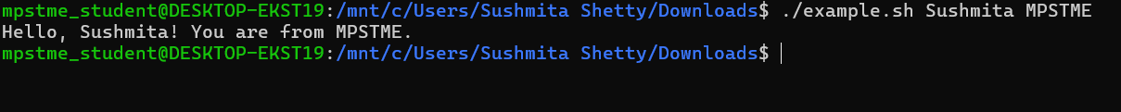

**We have succesfullt executed the shell script locally with no parameter , one parameter and two parameters.**

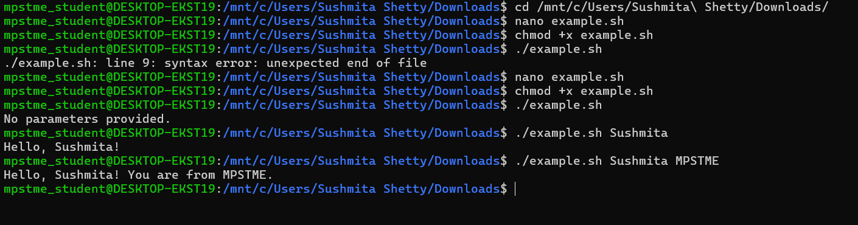

**Part 3 : Parameterize the Build and Pass Parameters to the Shell Script**

**Parameterize Build : In this program we are going to see how to provide parameters during runtime to your shell script or java program.**

**First create a .sh file in downloads**

**Then do the sudo nano command and permission access command then create it the same in the Jenkins**

**Solution:**

**1: Use sudo to Edit the File**

1. **Open Terminal.**
2. **Use sudo to Edit the File:**

sudo nano /var/lib/jenkins/workspace/example2/example2.sh



1. **Enter Your Script**: Replace any existing content with the following:

#!/bin/bash

echo "Hello, $1 from $2!"

1. **Save and Exit**:

* Press Ctrl + X, then Y to confirm changes, and Enter to exit.

1. **Set Permissions**: If necessary, you may also need to set the executable permissions using:

sudo chmod +x /var/lib/jenkins/workspace/example2/example2.sh



1. **Verify the Script** Before proceeding to Jenkins, let’s confirm that the script is correctly set up.

cat /var/lib/jenkins/workspace/example2/example2.sh

**Now go to the jenkin dashboard click on the failed job i.e example3 select that**

**Go to configure on left side:**

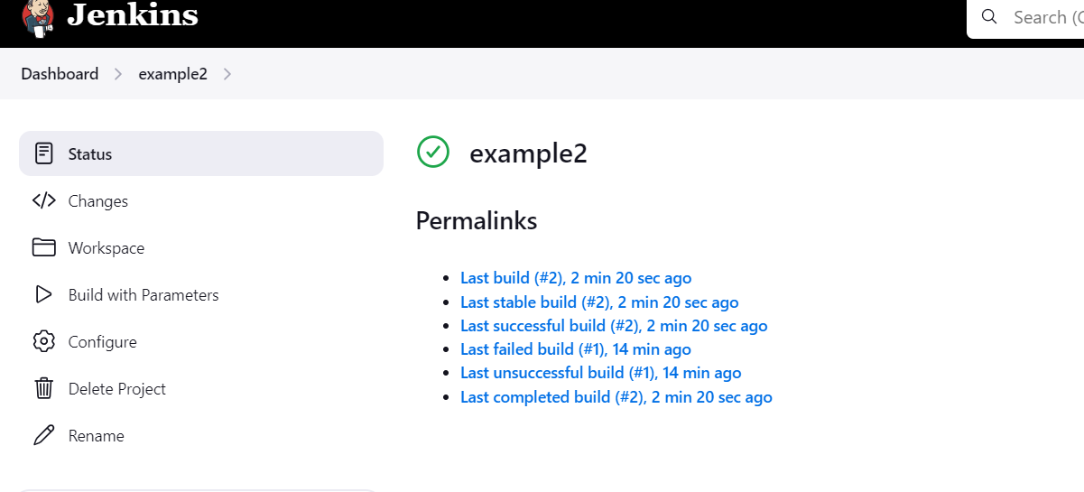

Again check every parameters:

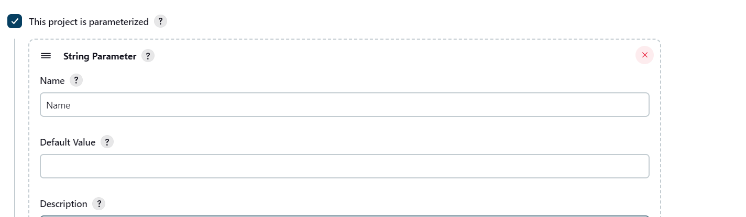

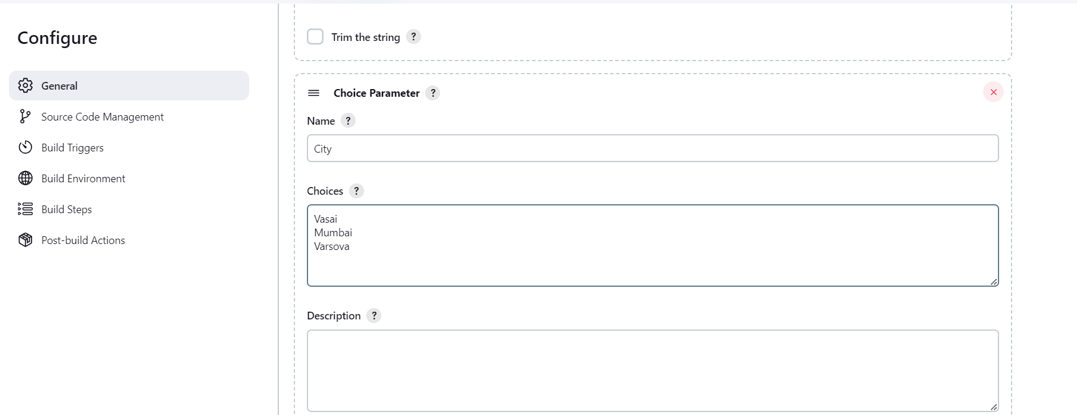

./example2.sh "$Name" "$City"

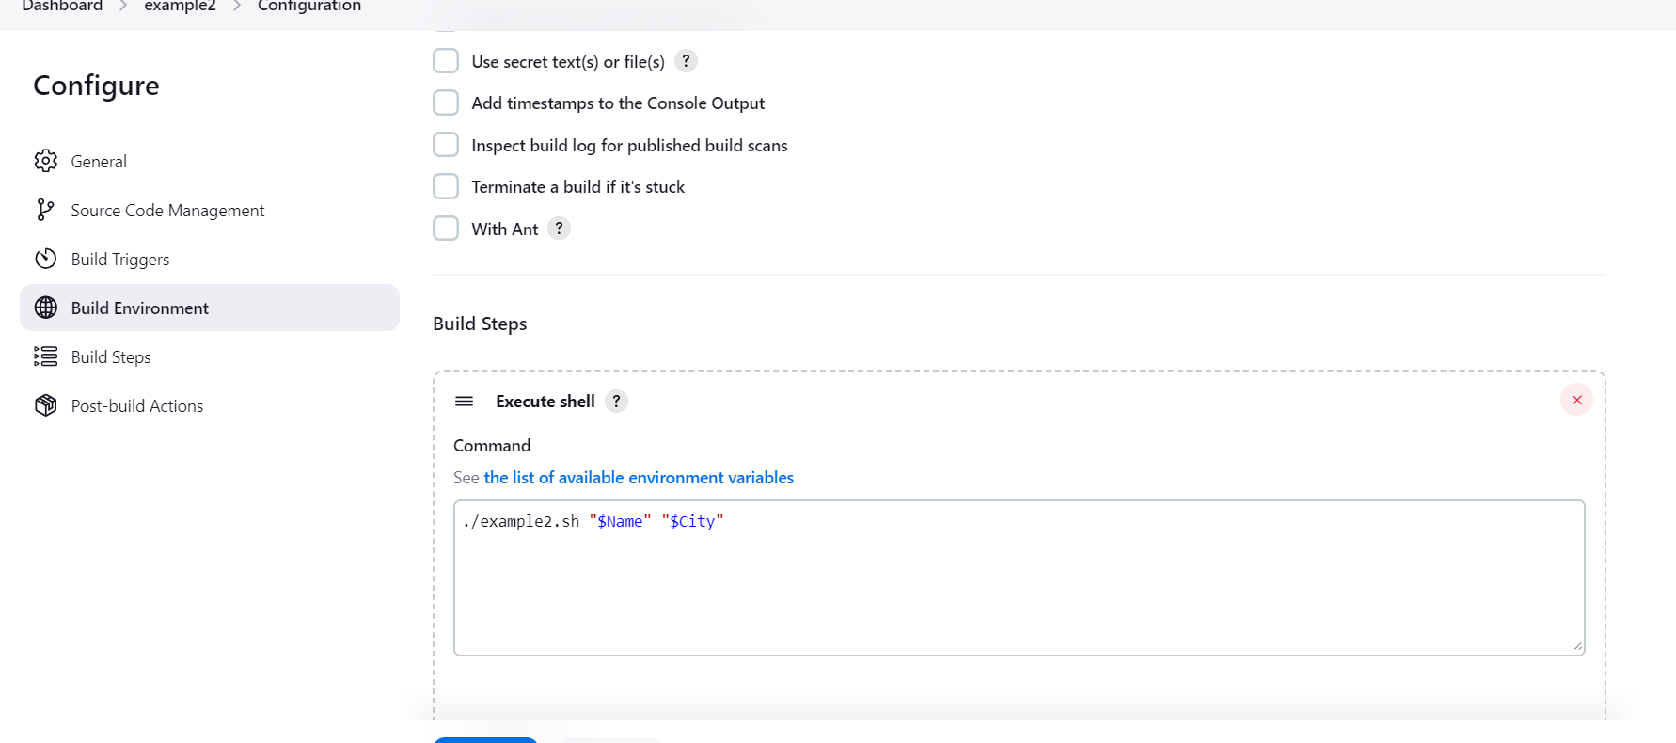

Then click on save :

Build is successful now:

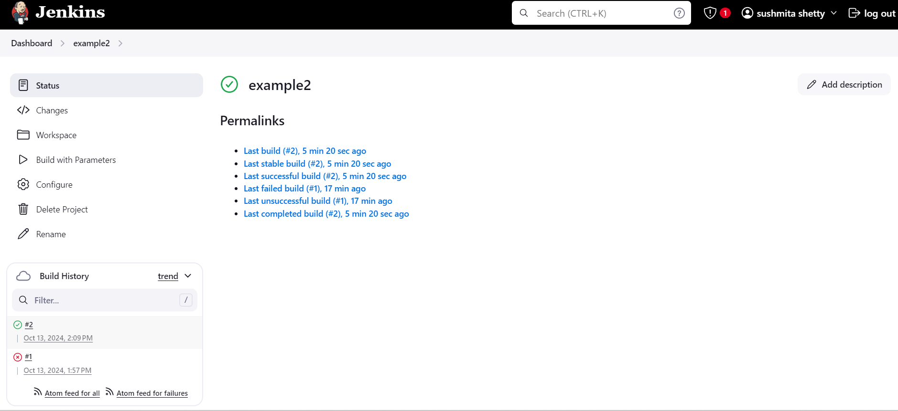

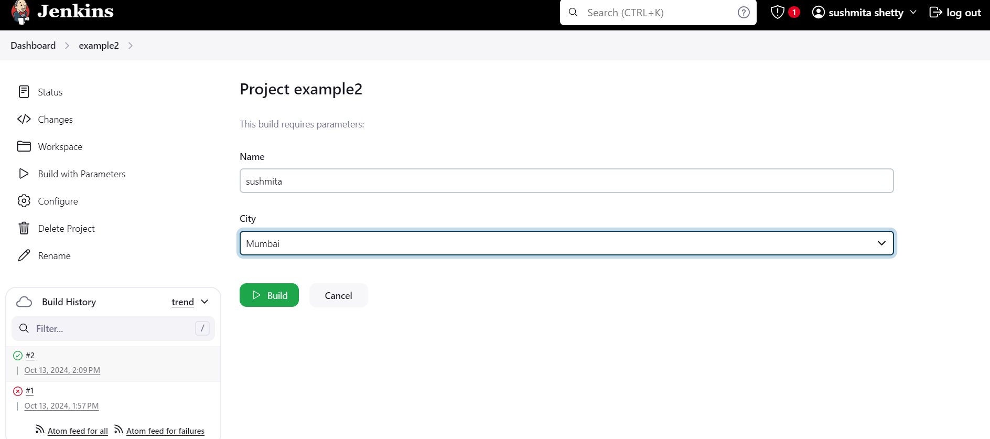

Check the console:

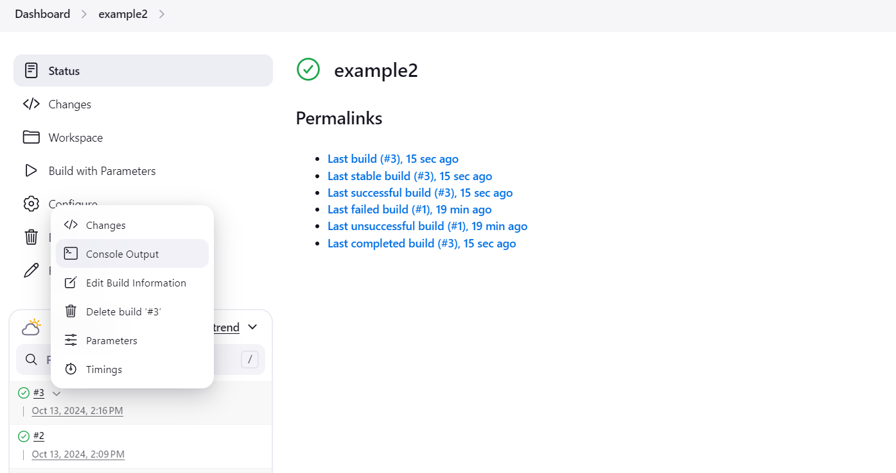

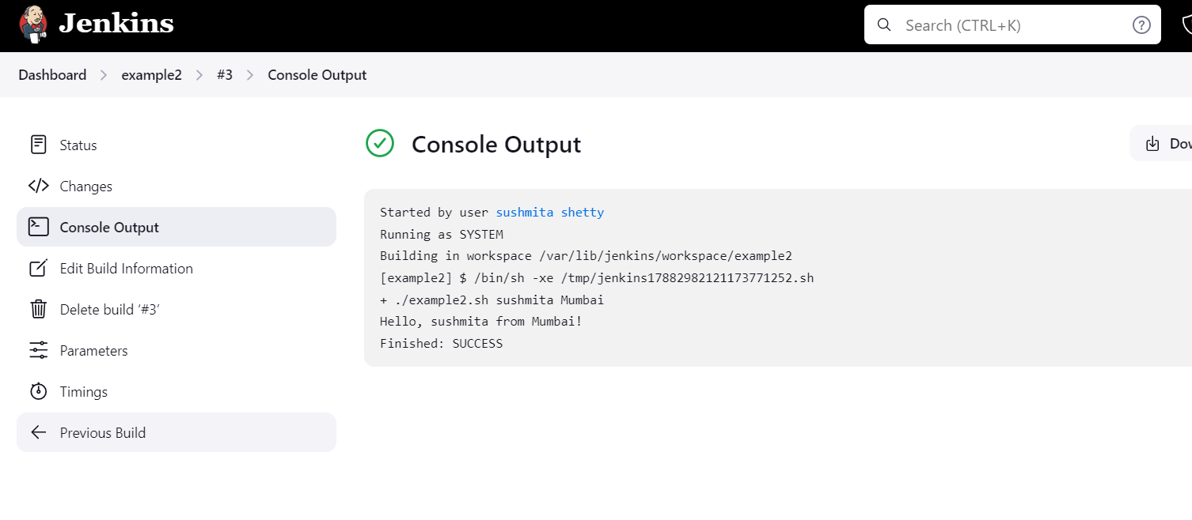

Done Jenkins